**Practical No: 6**

**Build a High-Fidelity Polished Wireframe Using any wire-framing Tools**

Step 1: Open Figma: Launch Figma and create a new project.

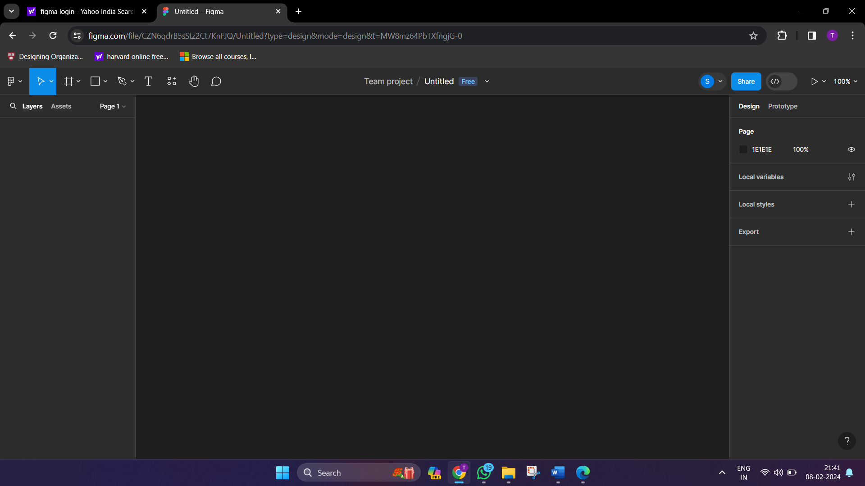

Step 2: Create a new frame to represent your design canvas. Typically, a low-fidelity design focuses on the overall layout and structure.

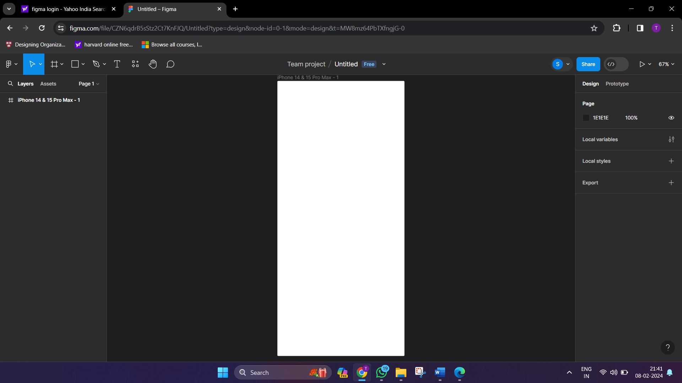

Step 3: Use real content, like images, colours and text to design the UI

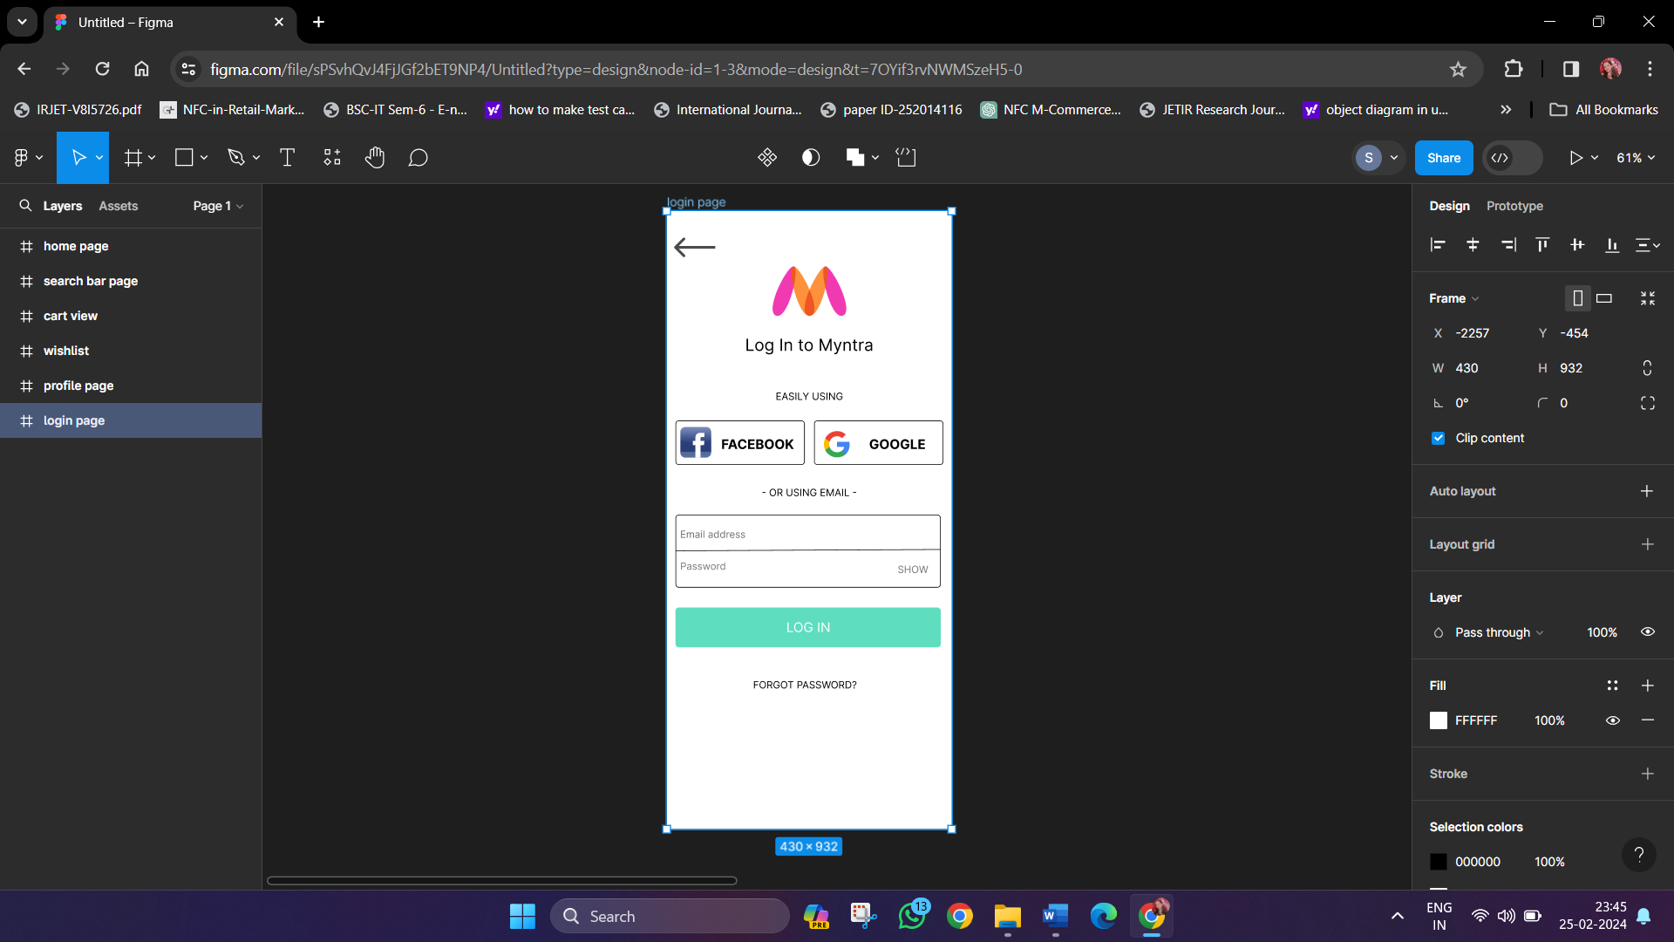

Step 4: Create multiple high fidelity pages of your selected application

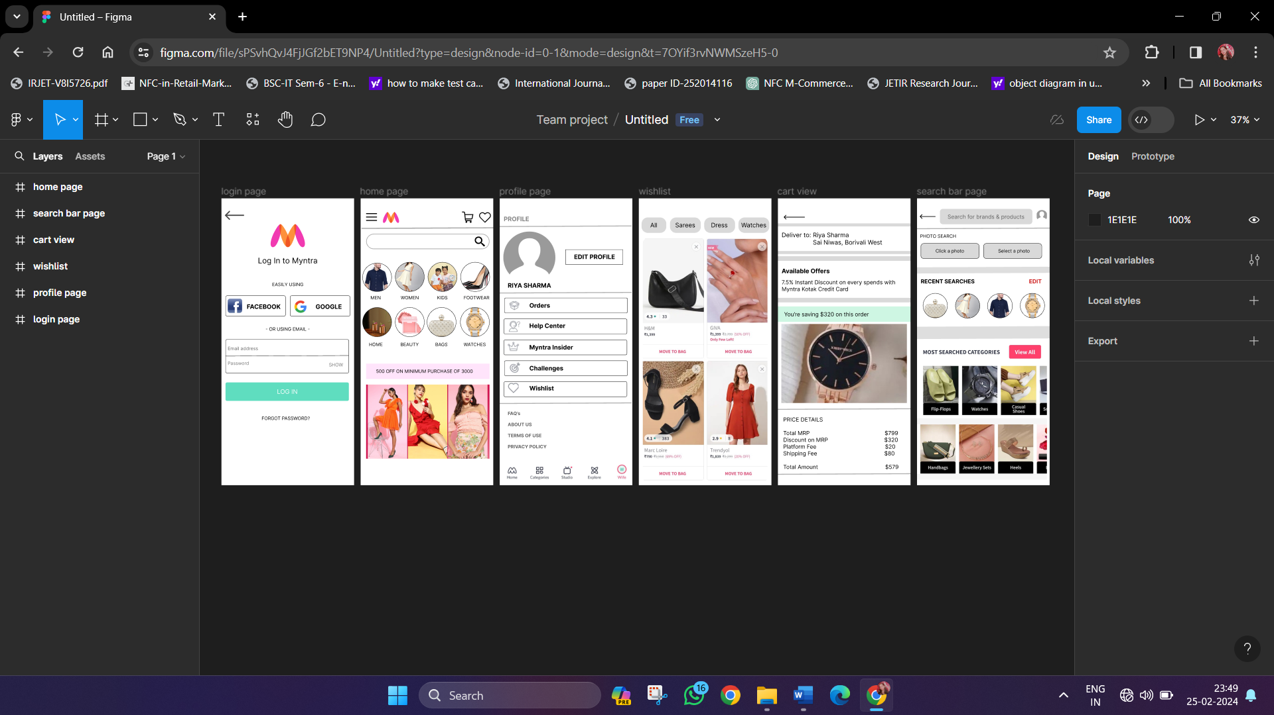

**Login Page Home Page**

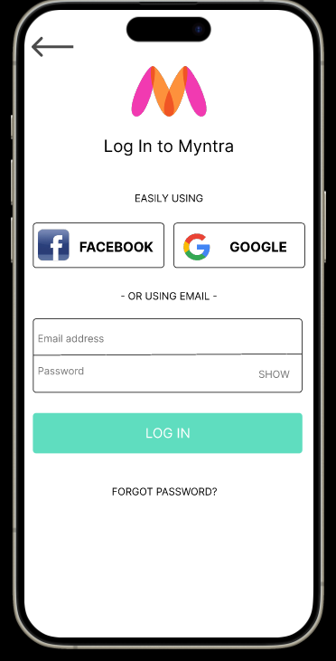 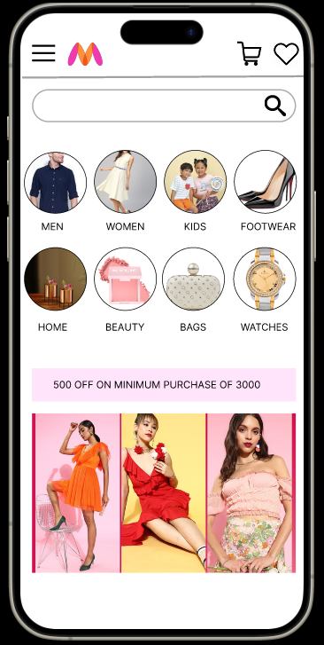

**Profile Page Wishlist**

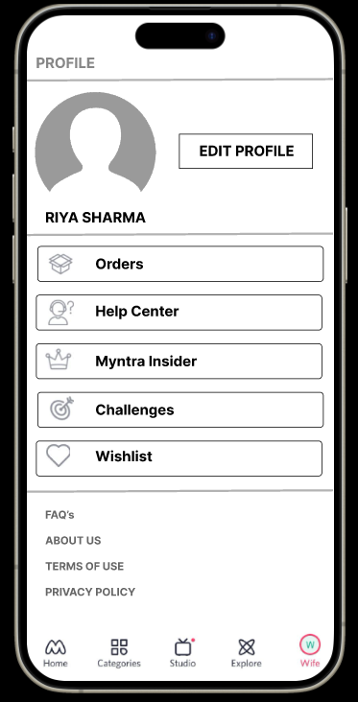 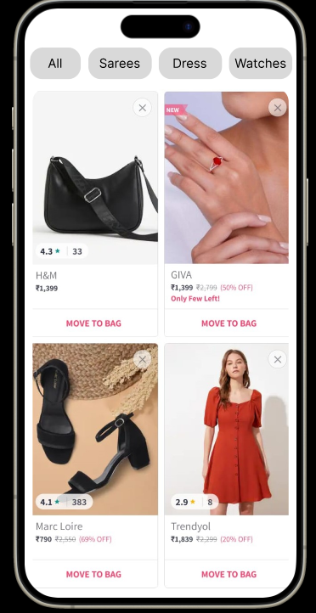

**Cart View Search Bar Page**

